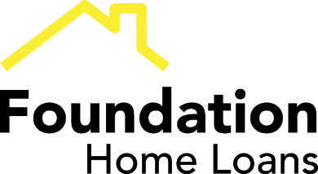

The challenges facing the green mortgage sector
Green mortgages and green finance are areas which represent huge potential for lenders, intermediaries and borrowers.
But there are no quick fixes as consumer awareness remains comparatively low and a number of misconceptions exist around cost, availability and accessibility which may restrict initial growth to a certain extent.
A major focal point in this awareness process has to be government-led. We know that there is a commitment in place to make Britain a carbon-neutral nation by 2050. Upgrading the UK’s existing housing stock, to make homes across the country more energy efficient, will be critical to that goal. A greater uptake in green mortgages will prove key in this journey and whilst there is widespread recognition of this throughout the lending community, we still have work to do to ensure we develop and integrate such products in the right way, with the right kind of backing.
View our latest buy to let rates
The private rented sector will play a huge role in this and that is why we, as a sector, need to evaluate ways in which we can reward those landlords who are making environmentally friendly choices. There has already been a real movement to increase the EPC ratings of rental properties, and as a lender we have recently introduced a ‘Green Reward’ remortgage product to help incentivise further progress. Essentially, if landlords commit to improving the energy efficiency of their properties, we will provide them with access to a product that delivers a competitive rate, with a reduced fee and a cashback amount.
TAKE ME TO THE GREEN MORTGAGE PAGE

FOR INTERMEDIARIES ONLY
© 2018 Foundation Home Loans is a trading style of Paratus AMC Limited. Registered Office: No.5 Arlington Square, Downshire Way, Bracknell, Berkshire RG12 1WA. Registered in England with Company No. 3489004. Paratus AMC Limited is authorised and regulated by the Financial Conduct Authority. Our registration number is 301128. Buy to let mortgages are not regulated by the Financial Conduct Authority. Calls may be monitored and recorded.

